

IPL 2025 Analysis

Assistant for Coaches



AFNAN YOOSUF

1. **Problem Statement**

IPL 2025 coaches face challenges in quickly analyzing player performance, match statistics, and opponent strategies during the tournament. An “Assistant for Coaches” is needed to provide real-time insights, predictive analytics, and data-driven recommendations to help coaches make informed decisions on team selection, batting order, bowling changes, and match tactics.

**2. Objectives**

* **Player Performance Analysis** – Track batting, bowling, and fielding stats to identify key strengths and weaknesses.
* **Tactical Recommendations** – Suggest batting orders, bowling changes, and field placements dynamically.

**3. Dataset Overview**

The dataset includes:

* The IPL 2025 dataset consists of two main files: **matches** and **deliveries**. The matches dataset contains 74 records with 22 columns, including details such as match date, venue, participating teams, toss and match winners, player of the match, top scorer, and best bowling performances.
* The deliveries dataset contains 17,183 records with 20 columns, providing ball-by-ball information like batting and bowling teams, striker, bowler, runs scored, extras, and dismissals.

Data Cleaning steps:

* **Initial Cleaning** – Replaced missing values in key columns and removed columns with excessive null values from both matches and deliveries datasets.
* **Data Standardization** – Standardized team names, player names, venues, and stage names for consistency.
* **Data Type Corrections** – Converted dates to proper date formats and ensured numeric fields were stored correctly.
* **Normalization** –
  + Created **Fact Tables**: matches and deliveries to store match-level and ball-by-ball data.
  + Created **Dimension Tables**: players, venues, stages, and teams for descriptive attributes.
* **Relationship Setup** – Defined primary and foreign keys to establish relationships between fact and dimension tables.
* **Final Data Model** – Optimized for Power BI to improve data integrity, reduce redundancy, and enable advanced analytics.

**4**. **Uses** **DAX Messures:**

1. **Dot Ball %**

shows the percentage of deliveries in which no runs were scored by the batsman.

1. **Dot Balls**

Dot balls are deliveries in cricket where the batsman does not score any runs.**Top of FormBottom of Form**

1. **Economy Rate**

Economy rate is the average number of runs a bowler concedes per over bowled.

1. **Is Bowler**

To get the bowler from deliveries table.

1. **Run Rate**

Run rate is the average number of runs a team scores per over in a cricket match.

1. **Total Wickets**

represent the total number of batsmen a bowler has dismissed during a match or tournament.

1. **Wickets by Type**

Wickets by Type refers to the classification of dismissals taken by a bowler, such as bowled, caught, LBW (leg before wicket), stumped, run out, or hit wicket.

1. **Matches Won**

Matches Won indicates the total number of matches a team or player has successfully won in the tournament

1. **Total Wins**

Total Wins represents the cumulative number of matches a team has won throughout the IPL 2025 season**.**

1. **Win %**

Win % represents the percentage of matches a team has won

1. **Total Balls Bowled**

Total Balls Bowled represents the total number of legal deliveries a bowler has bowled during a match or tournament (excluding wides and no-balls).

**Relationships** are built on:

* Match and deliveries table is fact table and connected with dimension table teams(team id),stage(stage id),players(players id),venues(venues id)

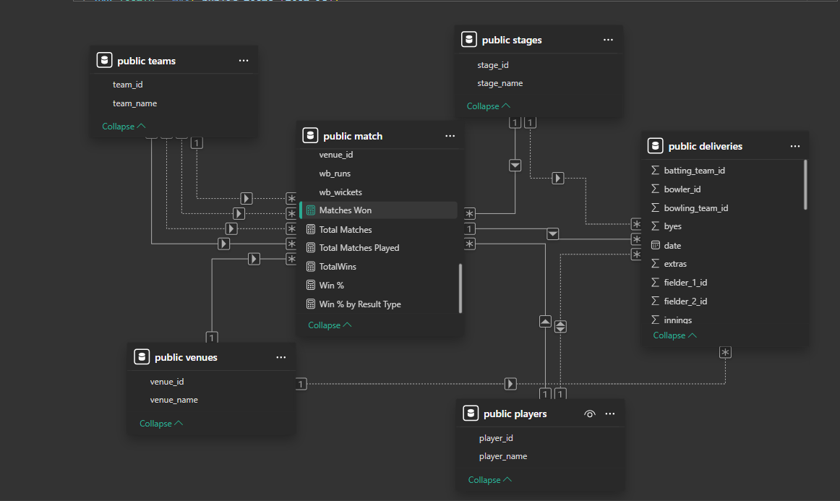

### Teams ****Overview****

* **Analyzed:** 71 matches were included in the analysis.
* **Win Percentage:** The overall win rate across teams is **42.86%**.
* **Scoring Rate:** Teams scored at an average run rate of **9.63 runs per over**.
* **Bowling Impact:** On average, teams took **12 wickets per match**.
* **Highest Run Rate:** Sunrisers Hyderabad (SRH) recorded the top run rate.
* **Lowest Run Rate:** Chennai Super Kings (CSK) and Kolkata Knight Riders (KKR) had the lowest run rates.
* **Top Winning Team:** Punjab Kings (PBKS) secured the highest number of wins (**11**).
* **Other Strong Performers:** Royal Challengers Bangalore (RCB) and Gujarat Titans (GT) followed closely in total wins.
* **Lowest Wins:** CSK and Rajasthan Royals (RR) had the fewest victories.
* **Wickets Taken:** PBKS and RCB led in total wickets taken, while RR had the fewest but maintained a competitive average wickets-per-team.
* **Filtering Options:** The dashboard supports filtering results by **Stage Name** and **Venue Name** for detailed insights.

## **Team Analysis**

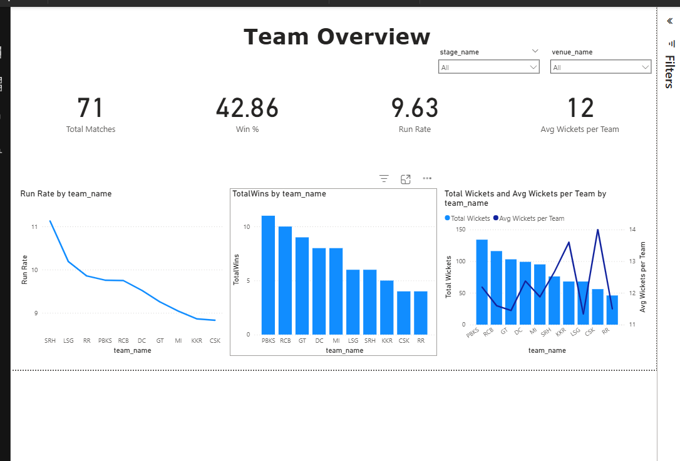

**📊 Breakdown by Team**

**1. Total Wickets and Economy Rate**

(Bar Chart: bottom-left)

* **SRH (Sunrisers Hyderabad)** has the **highest number of total wickets** (≈37) but with a moderate economy rate.
* **PBKS and LSG** also follow with a good number of wickets.
* **GT, MI, and RR** show lower total wickets.
* Economy rates across teams seem fairly consistent, ranging around 9–10.

**2. Dot Ball % by Team**

(Middle bar chart)

* **CSK, MI, and KKR** have the **highest dot ball percentages**, indicating tight, economical bowling.
* **LSG and SRH** have comparatively lower dot ball percentages.

**3. Wickets by Type**

(Stacked bar chart: bottom-right)

* Most common wicket type: **Caught** (dark blue).
* **Bowled and LBW** are the next common types.
* Teams like **DC, MI, and KKR** have a balanced distribution of wicket types.
* **Retired hurt** is extremely rare.

**🎛️ Player Filter (Top Right)**

* A dropdown allows filtering the entire dashboard by individual **player_name** — currently set to “All”.

## **Team Analysis**

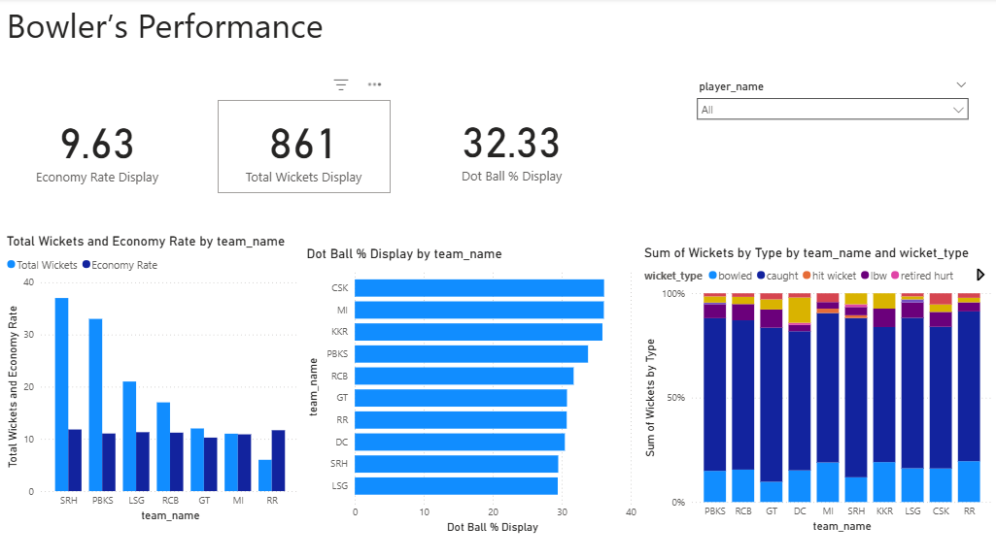

**Conclusion**

The performance analysis reveals that:

* **PBKS (Punjab Kings)** and **RCB (Royal Challengers Bangalore)** are among the best-performing teams, with the highest number of wins and strong bowling performance.
* **SRH (Sunrisers Hyderabad)** leads in total wickets, showcasing the strongest bowling attack, but has a relatively lower win count, suggesting a gap in converting bowling dominance into match victories.
* **CSK (Chennai Super Kings)**, while having the **highest dot ball percentage**, struggles with **run rate** and **total wins**, indicating difficulty in capitalizing on pressure-building with actual wickets or effective batting.
* **RR (Rajasthan Royals)** shows the weakest performance overall, with the lowest number of wins and a poor bowling contribution.
* Most dismissals come from **caught wickets**, followed by **bowled** and **LBW**, across all teams.
* Teams with a **balanced approach**—good economy, consistent wickets, and efficient run-scoring—tend to win more matches.

Overall, teams need to strike a balance between **tight bowling (dot balls & economy)** and **wicket-taking ability**, while maintaining a competitive **run rate** to increase their chances of winning matches.